/* --COPYRIGHT--,

* Copyright (c) 2019, TAPIT Co., Ltd.

* https://tapit.vn

* *************** I2C_CommunicationWithLCDI2C16x2 ****************

* Description: Use the lcd library to display any string

* Version: 1.0

* Author: Hang Tran

* Release: May 27, 2019

* Built with CubeMX Version 5.2.0 and Keil C Version 5.26.2

*****************************************************************

*/

**STM32CUBEMX:**

Step 1:

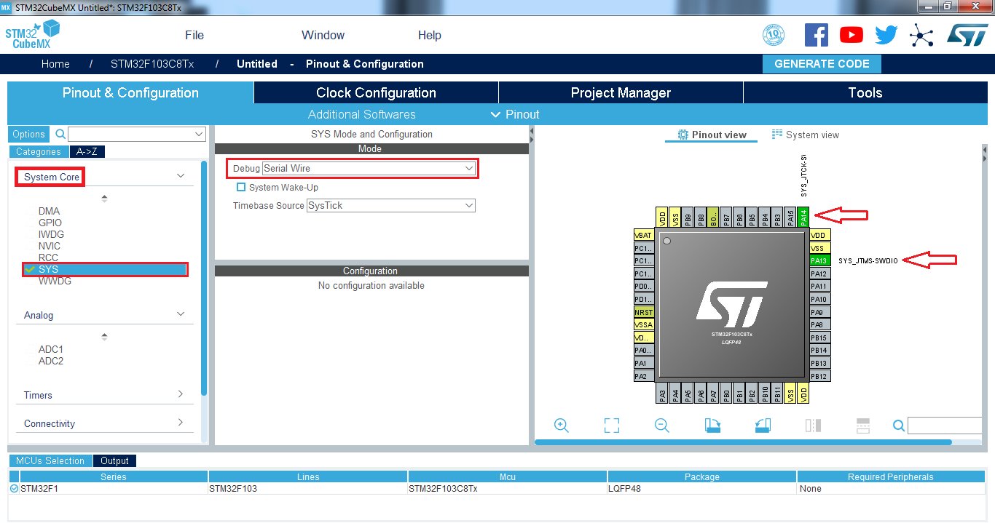

Step 2:

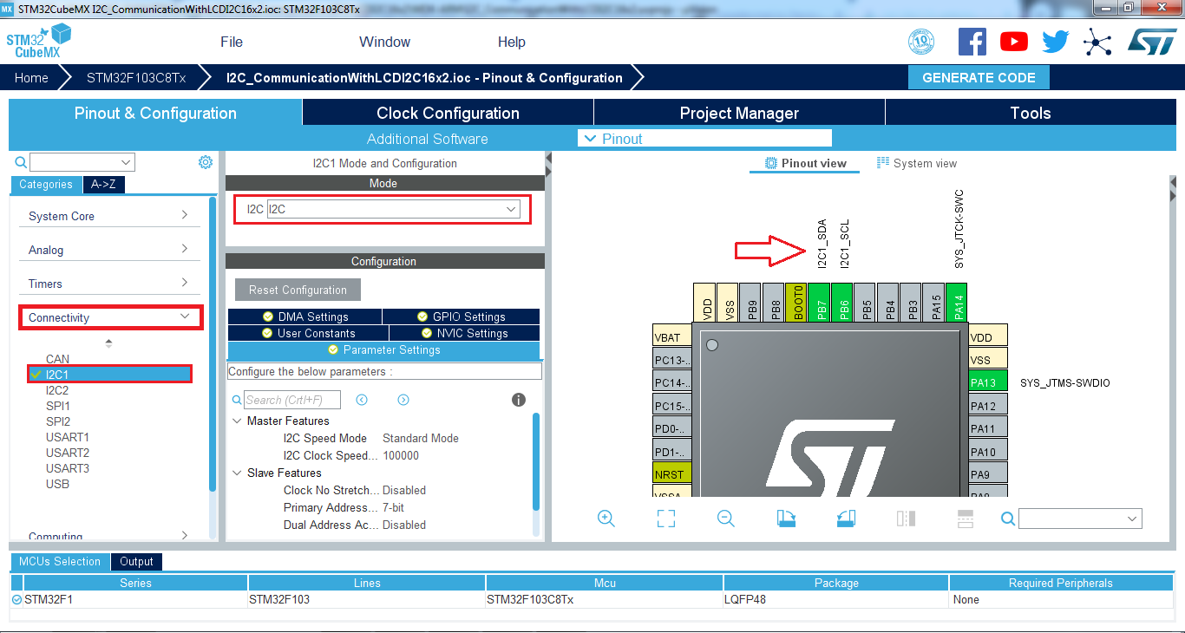

Step 3:

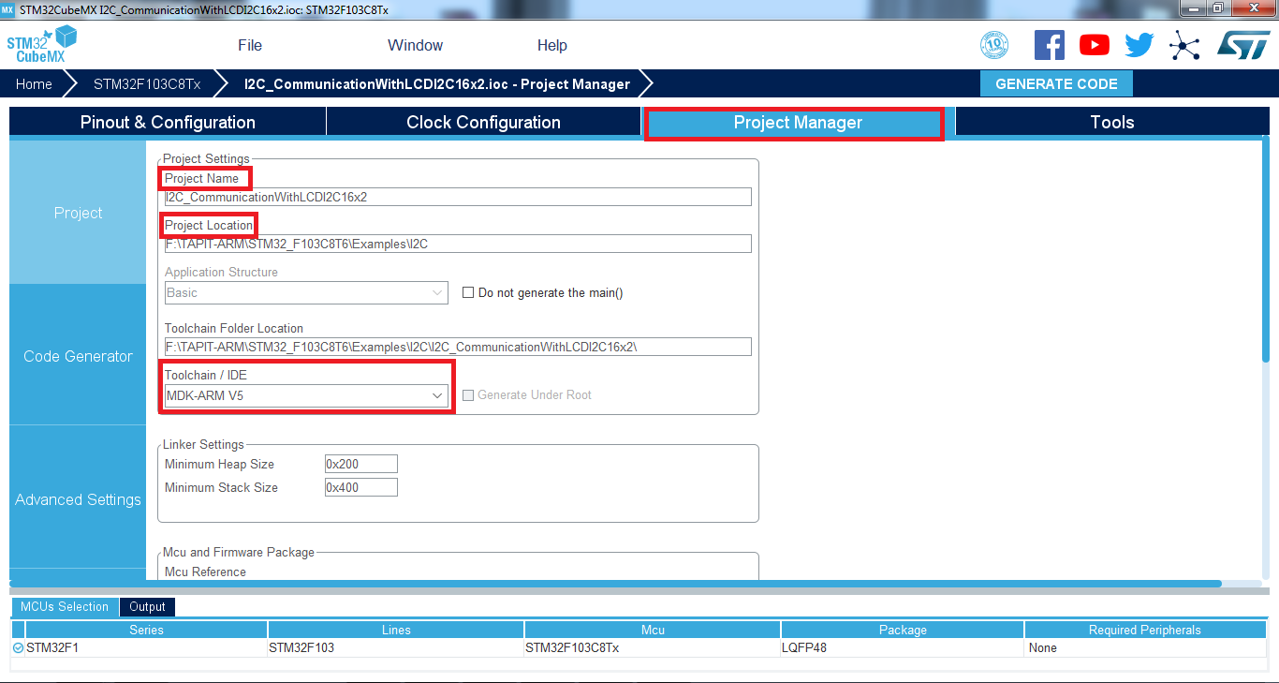

Step 4:

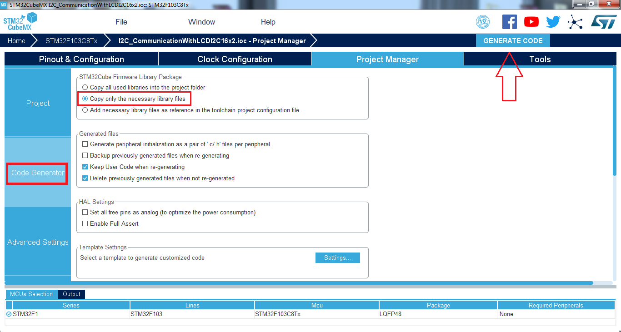

**KEIL C UVISION:**

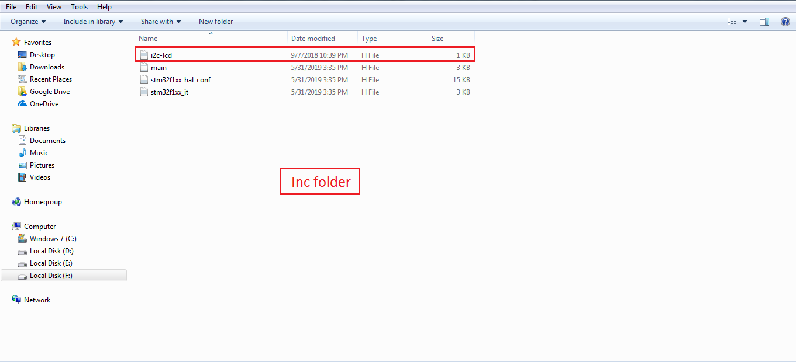

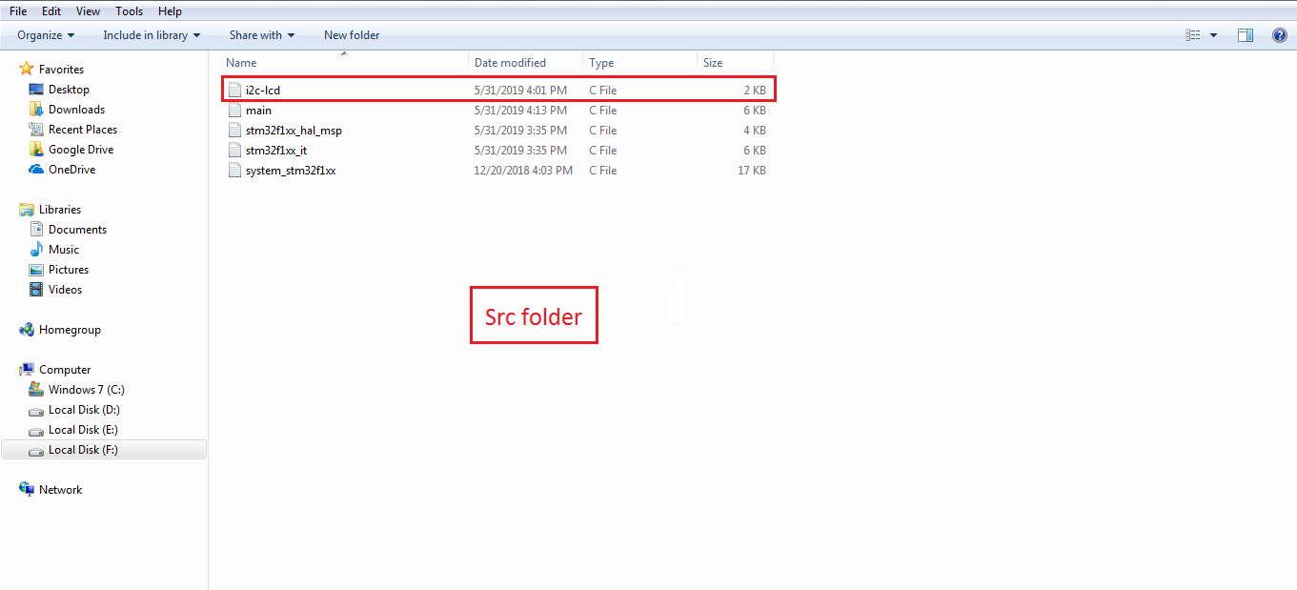

**RESULT:**

